

Marketing Intelligence

1 | P a g e

Table of Contents

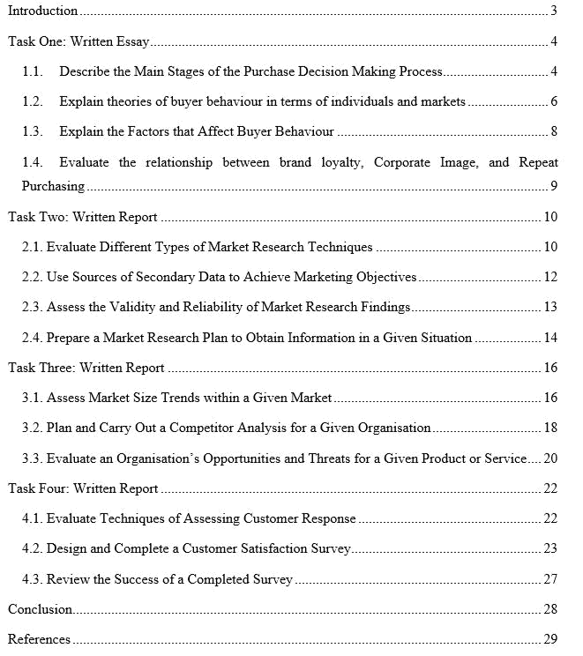

2 | P a g e

Introduction

Business organisations need to have idea about the market, behaviour of the customers, techniques of market research, and so on to be successful. The knowledge and capabilities of implementing the knowledge about those issues can be described as the marketing intelligence (Padua, 2014). Tesco is one of the leading supermarket of UK and the researcher has selected it as the organisation to complete the report. The researcher will describe about the buyer behaviour and purchase decision making of the customers of Tesco. In addition, the market research techniques of Tesco will be assessed here. The assessment of market size and future demand will help to understand about the condition of Tesco in the supermarket industry. Finally, the researcher will measure the satisfaction of the customers toward Tesco.

3 | P a g e

Task One: Written Essay

1.1. Describe the Main Stages of the Purchase Decision Making Process

The customers do not go to the market and purchase the products directly. There are some stages that are completed by the customers before taking decision of purchasing any products and services. The stages of purchase decision making process of customers of Tesco is discussed below.

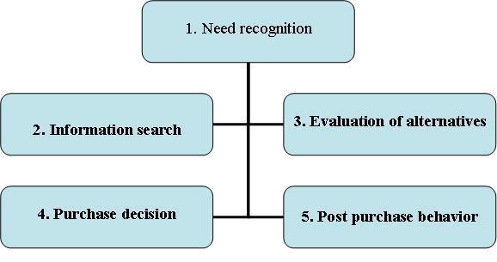

Figure 1: Stages of Purchase Decision Making

Source: (Widing, 2003)

Need Recognition: At first, the customers feel that they need any particular product and this called the need recognition stage of purchase decision making.

Information Search: When the buyer feels the need of any product then he/she tries to collect information about where the product will be available.

Evaluation of Alternatives: While collecting information about the product, the customers will get idea about products of different companies. At that point, the customers will evaluate that product of which companies will fulfill the needs effectively.

Purchase Decision: After evaluating the alternative, the customer will take the decision of purchasing any particular product.

4 | P a g e

Post Purchase Behaviour: Post purchase behaviour indicates that whether the customers are satisfied with the products or not.

5 | P a g e

1.2. Explain theories of buyer behaviour in terms of individuals and markets

Tesco will have to get idea about the behaviour of the customers before setting any strategies for the customers. For that reason, the researcher will explain some theories of buyer behaviour of customers for Tesco.

Stimulus Response Behaviour Model

Stimulus Response Behaviour Model of consumer behaviour indicates that the marketing and other stimuli influence the characteristics and purchase decisions of the buyers and the buyers take the decisions of purchasing the products.

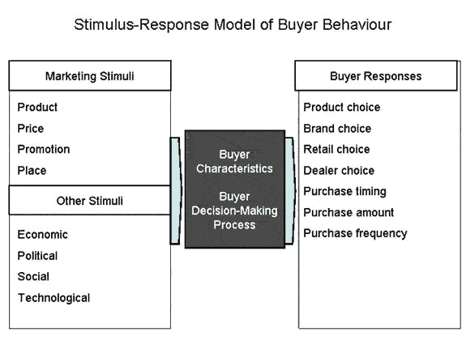

Figure 2: Stimulus Response Model of Buyer Behaviour

Source: (Evans, Jamal and Foxall, 2009)

The quality of the product, affordable pricing, effective promotion, availability of products, and so on are some of the stimuli which influence the customers to response and the response comes with purchasing the products and services. At the same time, the economic and social factors work as the stimuli to take the decision that whether they will response to the product or not.

6 | P a g e

Diffusion and Innovation Model of Response

Diffusion and Innovation model of consumer behaviour deals with the tendency of adopting the innovation of the customers. Different customers have different behaviour towards innovation which will be the main concern of the model.

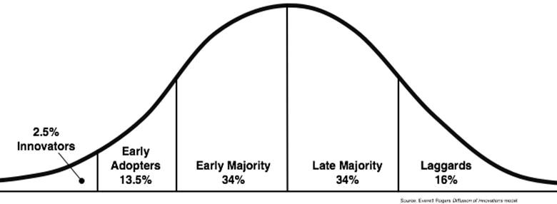

Figure 3: Diffusion and Innovation Model of Customer Behaviour

Source: (Changing customer behaviour, 2007)

Inventors are the leader type customers who adopt the new products first. The early adopters are also leaders of customers because they also have the courage to check the quality of new products. Early majority is the portion of customers who purchase the products if they get the information that products are good. Late majority focus on the fact that whether they actually need the products or not and then go for the purchase decision. Laggards are the customers who do not have any attraction to new products. And, they are happy with the existing products. Tesco can set their strategies for the customers by considering the theory.

7 | P a g e

1.3. Explain the Factors that Affect Buyer Behaviour

There are different factors which directly affect the decision of purchasing any products and services. For that reason, it is crucial to explain the factors which affect the behaviour of the customers of Tesco.

Psychological Factors include motivation, learning and socialization, attitudes and beliefs which have direct impact on the decision of buyers. If the buyers are motivated about any particular organisation, they will purchase the products. At the same time, the attitude of the customers shape the decision of purchasing products.

Social factors include environment, community, family, organisation, society, and so which have direct impact on buyer behaviour (Siji, 2015). The environment of an area set the demand of the people and people purchase products based on that demand. Family members influence with their decisions about which products should be purchased.

Economic Factors include the income, expenses, and financial liabilities, and so on of the buyer. If the buyers have enough money, then they can take decisions easily by not considering the pricing factors. On the other hand, with little income it becomes difficult to take purchase decisions.

Lifestyle Factors of the buyers influence their decisions because people purchase products which suit their lifestyle. For that reason, the business organisations like Tesco need to consider the lifestyle of the customers while offering products and services in the market.

Cultural Factors include the values, norms, beliefs, and so on of a particular area which shape the behaviour of the customers of that area. Each culture has specific way of living which influence the behaviour of the customers.

8 | P a g e

1.4. Evaluate the relationship between brand loyalty, Corporate Image, and Repeat

Purchasing

Brand Loyalty means that the customers are committed to specific brand and purchase products of that brands repeatedly. For that reason, all business organisation including Tesco takes some loyalty programs to ensure that the customers will be loyal to the brand.

Corporate Image is the set of impression that are left by the business organisations in the mind of the customers (Kazanjian, 2013). In other word, the perception of customers about the company can be termed as the corporate image. Tesco and other business organisations have some strategies like quality products, better services, and media coverages, and so on to ensure good corporate image for the organisation.

Repeat Purchasing is the situation when the customers purchase the product of specific company again and again. Business organisations always want that the customers will be satisfied with the products and will ensure repeat purchase of the products.

There are strong relationship between the brand loyalty, corporate image, and repeat purchase. When the customers have good image about the products and services of a particular organisation, then the customers will have brand loyalty. In addition, brand loyalty ensures that customers purchase the products of same brands. So, Tesco will have to build good corporate image which will make the customers loyal to the organisation. And, customers will purchase the products of the company repeatedly.

9 | P a g e

Task Two: Written Report

2.1. Evaluate Different Types of Market Research Techniques

Objective of Research

The objectives of the research is to find out the behaviour of the customers and how the behaviour of customers influence the purchase decision of the customers.

Evaluation of Types of Market Research Techniques

There are different of types of market research techniques but all the techniques will not be suitable for Tesco. For that reason, the evaluation of those techniques for Tesco is given below:

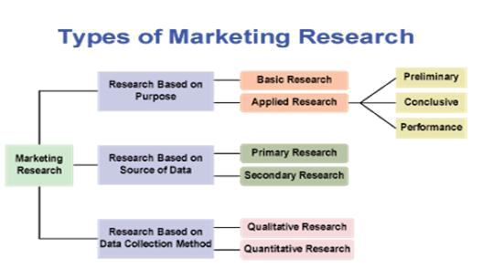

Figure 4: Types of Market Research

Source: (Malhotra, 2017)

Basic Research: Basic research is the scientific research through which the prediction of natural and other issues are done which are related with the business. The basic research will be benefited for Tesco while conducting research about the progress of a new product.

Applied Research: Applied research is done to solve any particular problems related to the business. For example: Tesco can go for the applied research to take decision about how BREXIT will affect the behaviour of the customers.
10 | P a g e

Primary Research: When the research is done with the data which are collected from primary sources, then the research is called primary research. This will help Tesco to get the actual data from the customers.

Secondary Research: When the research is conducted by collecting data from the secondary sources, then the research is known as the secondary research. Tesco will be able to get idea about particular issue through this research.

Qualitative Research: The research which is non-numeric and descriptive in nature is known as the qualitative research. For example: Tesco will be able to understand that the customers are satisfied with the products and services or not.

Quantitative Research: The numeric research is known as the quantitative research which gives clear idea about any topic. For example: Tesco will be able to understand the extent of satisfaction of the customers.

11 | P a g e

2.2. Use Sources of Secondary Data to Achieve Marketing Objectives

Tesco will be able to achieve the objectives of the research through using data of secondary sources. To understand about the behaviour of customers and the influence of behaviour on the purchase decision making of customers, Tesco can use following sources.

Internal Sources

Sales Data: Sales data of Tesco will give the idea that whether the customers have positive or negative behaviour towards the products and services of Tesco.

Financial Data: Financial data like amount of sales, collected money, and so on will give the idea that whether the customers have positive behaviour towards the products or not (Hair, 2014).

Transportation Data: Information about transportation of products and services will give idea that customers of which area have more positive behaviour towards the products and services of Tesco.

Storage Data: Tesco has stored data about the customers in previous time. For that reason, Tesco can use the data of different year to understand behaviour of customers.

External Sources

Government Statistics: Government statistics about present condition of supermarkets of UK will give idea about behaviour of the customers.

Trade Associations: The trade associations of different area sometimes go through the research to get idea about any particular issue.

Commercial Services: There are some commercial services for market research. Tesco can take information from those commercial services to conduct the research.

Journals and Literature: There are different journals and literature related to the behaviour of the customers. Tesco can take help those to get idea about the behaviour of customers.

12 | P a g e

2.3. Assess the Validity and Reliability of Market Research Findings

There will be no benefits of the research if the findings of the market research is not valid and reliability. The validity of the market research findings depends on various issues:

Selection of Valid Objectives: The research will be valid if the researcher can select specific objectives of the research. Without selecting valid objectives, it is not possible for the Tesco to conduct a valid research.

Methodology Selection: The researcher will be able to conduct the valid research and the result will not be reliable if he failed to select the right methodologies to conduct the research.

Sources of Data: The validity and reliability depends on the sources of data. If the sources of data are not reliable, the result of the research will not be reliable (Rossi, Wright and Anderson, 2013). For that reason, the researcher will have to select the valid sources of data to get reliable findings.

Sampling Process: If the sampling process is not perfect, then the result of the research will not be perfect. For that reason, the researcher will select that whether the probability or non-probability sampling process will be applied to ensure validity and reliability.

Perfect Analysis Process: The collected data needs to analyse perfectly because if the analysis of the data is not perfect, then the organisation will not get valid result from the research.

Linking the Findings with Objectives: Validity and reliability of the research also depend on the fact that whether the findings of the research has matched with the objectives of the research.

13 | P a g e

2.4. Prepare a Market Research Plan to Obtain Information in a Given Situation

Background of the Research

Background of the research include the information about the basic of the topic of the research. Customer behaviour has huge impact on the purchase decision making and the success of the organisation depends on how the organisation can influence the decisions in its favor. The research will done that issues.

Rationale of the Research

Rationale of the research indicates the importance of the topic of research. Tesco and other business organisations will be successful if they are able to understand the behaviour of the customers. So, marketing of Tesco should conduct the research in effective manner to get idea about behaviour.

Objectives of the Research

Objectives of the research indicates that goals that the researcher want to achieve after conducting the research. Here, the objective of the research is to understand the behaviour of the customers and how the behaviour influence the decision making of the customers.

Methodology of the Research

The methodology indicates the methods of conducting the research. The mix of qualitative and quantitative approach will be used to conduct the research (Doman, Dennison and Doman, 2006). At the same time, both primary and secondary sources will be used for collecting the information.

Analysis and Findings of the Research

After collecting the information through using different methodologies, the researcher need to analyse the data using excel, SPSS, and so on to present the data.

Time Frame of the Research

The activities of the research are divided into different parts and each activity has specific time period to complete. Gantt chart is used by the researcher to provide the timeframe of the research.

14 | P a g e

Conclusion and Recommendation

In conclusion, the researcher present the overall activities that are performed in the research. And, recommendation indicates how the organisation will implement different aspects of the research.

15 | P a g e

Task Three: Written Report

3.1. Assess Market Size Trends within a Given Market

Tesco is the part of retail industry of UK which is one of the leading industry. So, it is important for Tesco to have idea about size and trends of the retail market.

Size of the Market

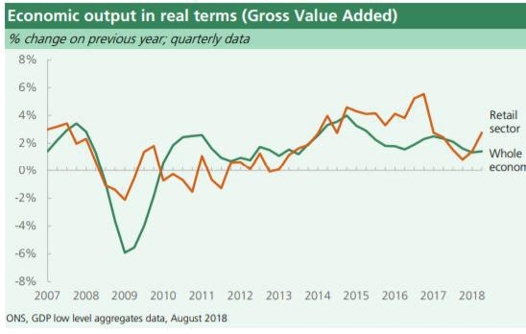

The total economic output of the retail sector was £92.8 billion in 2017 and the amount is 5% of the total GVA of UK. The amount of economic output was low due to the effect of financial crisis during the 2009-12. But, the retail sector has recovered the issue and started to grow from them. But, in recent time, the output is increasing slowly due to the impact of BREXIT.

Around 2.8 million people of Great Britain is related with the retail sector of the country and the number is increasing from previous time (Facts, 2019). At the same time, the employment ratio in different parts of Great Britain is even.

There are around 319125 organisations of retail business in the retail sectors in 2018 which is 5.6% of overall business of the country (Facts, 2019). Though most of the retail market is captured by the leading retail chains of the country like Tesco and others. In 2011, the grocery market was worth 163.8 billion British pounds, which is forecasted to rise to 196.9 billion British pounds by 2021.

16 | P a g e

Trends of Retail Market

Shop Closure: Small shops of retail industry are being closed because they are not able to survive with the strong competition of the retail sector.

Internet Retailing: Most of the retail chain has strong presence in internet, social media, and so on. So, Tesco will also follow the trends of being online organisation.

Change Behaviour of Consumers: The behaviours of the customers have changed in recent years because the advancement in technologies, financial condition, and so on. So, Tesco need to consider the changing behaviour of the customers to deal with the situations.

Changing Environment of Supermarket: The environment of the supermarket has become more competitive because of the rise of some new supermarket.

17 | P a g e

3.2. Plan and Carry Out a Competitor Analysis for a Given Organisation

The competitive analysis for Tesco will include the comparison of Tesco with its leading competitors in the supermarket industry.

 | Tesco |  |  |  |  |  |  |  | Sainsbury |  |  |  |  |  |  |  | ASDA |  |  |  |  |  |  |  |  | Morrison’s
 | Tesco | is | the |  | largest |  |  |  | In | 2018, |  |  | Sainsbury |  |  |  | ASDA |  |  | is | the |  | third |  |  | Morrison |  |  |  | can |  | be
 | retail | supermarket |  |  |  |  | at |  | was | the second |  |  |  |  | best |  | largest retail chain of |  |  |  |  |  |  |  |  | defined as |  |  |  | the | third
 | the end of 2018. The |  |  |  |  |  |  |  | retailer |  | of the |  |  |  | UK |  | UK | but 2nd |  |  |  |  | best |  |  | highest competitor of
 | organisation sells |  |  |  |  |  | all |  | with |  | the |  |  | 16.1% |  |  | competitor |  |  |  | of | Tesco. |  |  |  | Tesco. |  | As |  | it |  | is
 | the | products |  |  |  |  | of |  | market |  |  | share. |  |  | In |  | The | market |  |  | share |  |  | of |  | vertically |  |  | integrated
 | grocery |  |  |  |  | and |  |  | addition, |  |  |  |  |  | the |  | ASDA |  |  | is |  | 15.7% |  |  |  | supply chain, so it has
 | merchandise. |  |  |  | It |  | is |  | organisation |  |  |  |  | is | well |  | which |  |  | indicate |  |  | that |  |  | been | able to capture
 | operating its business |  |  |  |  |  |  |  | known for its strategy |  |  |  |  |  |  |  | there |  |  | is |  | strong |  |  |  | the | market. |  |  |  |  | The
 | activities |  |  | with |  | 7000 |  |  | of experimentation of |  |  |  |  |  |  |  | competition |  |  |  | between |  |  |  |  | organisation has own
 | stores |  | across |  |  |  | the |  | layout of |  |  |  | the stores |  |  |  | ASDA and Sainsbury |  |  |  |  |  |  |  |  | manufacturing
 | world | though |  |  |  |  | the |  | (Arrow |  | and |  |  | Hahn, |  |  | and this will affect the |  |  |  |  |  |  |  |  | facilities |  | which |  |  |  | has
 | major | presence |  |  |  | is | in |  | 2007). It is well |  |  |  |  |  |  |  | overall competition of |  |  |  |  |  |  |  |  | influenced |  |  |  | overall
 | UK. It has adopted the |  |  |  |  |  |  |  | known |  |  | for |  | being |  |  | the market. As it is the |  |  |  |  |  |  |  |  | activities |  |  |  | of |  | the
 | penetrative |  |  |  | pricing |  |  |  | customer |  |  |  |  | friendly |  |  | subsidiary |  |  |  |  |  |  | of |  | organisation. The cost
 | strategy |  |  | and |  | has |  |  | organisation. |  |  |  |  | It | is |  | Walmart, so it ensures |  |  |  |  |  |  |  |  | of the products is low
 | capitalized |  |  | the |  | retail |  |  | operating |  |  |  | with 1304 |  |  |  | the |  |  | penetrative |  |  |  |  |  | for | the |  |  | Morrison
 | revolution |  |  | of | 1990s. |  |  |  | stores |  |  | and |  |  | has |  | pricing |  |  | strategy |  |  |  | to |  | because |  | of |  | its | own
 | In addition, the value |  |  |  |  |  |  |  | reputation |  |  |  |  |  | for |  | capture the market. It |  |  |  |  |  |  |  |  | production and strong
 | based | strategy |  |  |  | has |  |  | convenience |  |  |  |  | goods. |  |  | is operating with 604 |  |  |  |  |  |  |  |  | relationship |  |  |  | with |  | the
 | helped |  |  |  |  |  | the |  | Along |  | with |  |  | offline |  |  | stores |  |  | and | the |  | main |  |  | farmers and suppliers.
 | organisation |  |  |  |  |  | to |  | competition, |  |  |  |  | it | is |  | slogan |  |  | of |  |  |  | the |  | Morison |  | is |  | operating
 | capture |  | the |  | market. |  |  |  | creating |  |  | competitive |  |  |  |  | organisation |  |  |  |  | is | that |  |  | around 700 stores and
 | Tesco | has |  |  | started |  |  |  | situation for Tesco in |  |  |  |  |  |  |  | save money and live |  |  |  |  |  |  |  |  | 500 | of | them |  |  |  | are
 | 2018 | with |  |  |  | 28% |  |  | online |  | also |  |  | because |  |  | better. |  |  | At | the |  | same |  |  | supermarket. Slowly,
 |  |  |  |  |  |  |  |  | the online selling has |  |  |  |  |  |  |  | time, |  |  | the |  | pricing |  |  |  | the | organisation |  |  |  |  | is

18 | P a g e

market share of the | boomed in | recent | strategy | of | the | going to increase the
supermarket industry. | past. |  | organisation |  | include | market share in the
 |  |  | everyday | low price |  | industry.
 |  |  | concept.

19 | P a g e

3.3. Evaluate an Organisation’s Opportunities and Threats for a Given Product or Service

Selection of the Product

The product for evaluating the opportunities and threats is Navy Ditsy Floral Shirt.

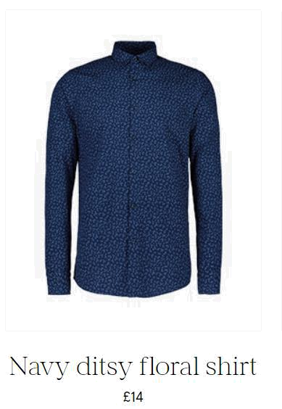

Opportunities of Tesco for Navy Ditsy Floral Shirt

The strategic alliance with the F&F will create the opportunities to offer more products to the customers and there will be more customers for the organisation.

Tesco can offer this shirt to the market where the customers want quality products in lower price.

It will create the opportunity to capture the customers with low budget for purchasing shirts.

20 | P a g e

There are opportunity for Tesco to capture the online market which is still growing in UK. For that reason, Tesco can take the opportunity of capture the online market sector through using the product

Emerging market area needs quality products and services because it helps to capture the customers. For that reason, Tesco can use this shirt in the emerging market so that customers can get quality product in affordable price.

Threats of Tesco for Navy Ditsy Floral Shirt

The economic condition of the customers always create threat the organisation of losing the market share (Vaněk, Mikoláš and Žváková, 2012). If the economic situation of the customers is bad, then they will not come to purchase this shirt.

The threats of competitors are always create problems for the organisation. ASDA, Sainsbury, and so on which are competitors of Tesco can bring same kind of shirt in their stores which will create threat of losing the market.

Due to the decrease of disposable income and increase the price of food products, the customers have less intention on buying clothing items. For that reason, the chances of selling the shirt will decrease for Tesco.

The price of raw materials has increased and it has direct impact on the price of the products. If Tesco could sell the shirt in lower price, then more customers would by the product. So, the increase of the price of raw materials has created threats for Tesco.

21 | P a g e

Task Four: Written Report

4.1. Evaluate Techniques of Assessing Customer Response

Business organisations need to assess the response of the customers to understand that the customers are satisfied with products and services or not. The evaluation of different techniques of assessing customer response is given here.

Post-Sale Survey: Post sale survey is the process where the organisation can take the opinion of the customers after selling the products. Tesco can use the technique in the stores where responsible persons will take the survey to get the response of the customers. Sometimes customers may not be interested to be part of the survey.

Complaint Handling: Handling the complaints of the customers can be good techniques of understanding about the response of the customers (Wong, 2002). If the amount of complaints is few then it can be understood that the customers are satisfied with the products and services of Tesco. In contrasts, if the number of complaints is high, then the customers are not responsive.

Customer Follow Up: Selling the product to the customer is not the last step for the salesmen of Tesco. After selling the products, the salespeople of Tesco should ensure that they are communicating with the customers to build strong relationship. At the same time, they will take follow up of the process to ensure better response from the customers.

Customer Care Services: There are many customer care services of Tesco which help the organisation to understand about the response of the customers about the products and services of the organisation.

22 | P a g e

4.2. Design and Complete a Customer Satisfaction Survey

Here, the researcher will prepare a questionnaire and complete the data collection through using the questionnaire.

Name of Respondent:

Sex

- male

- female
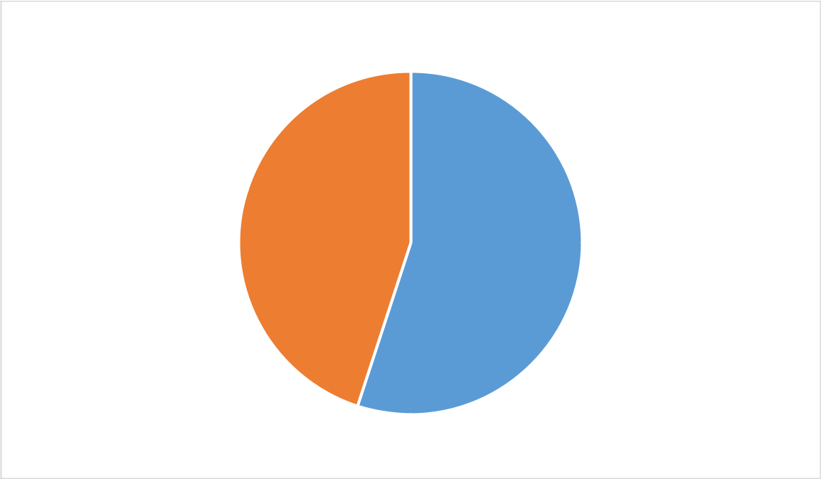

Sex

Male Female

How you will describe the products and services of Tesco

- buggy

- Fine, but there are some issues

- Fine

- Great

- Life-saving

23 | P a g e

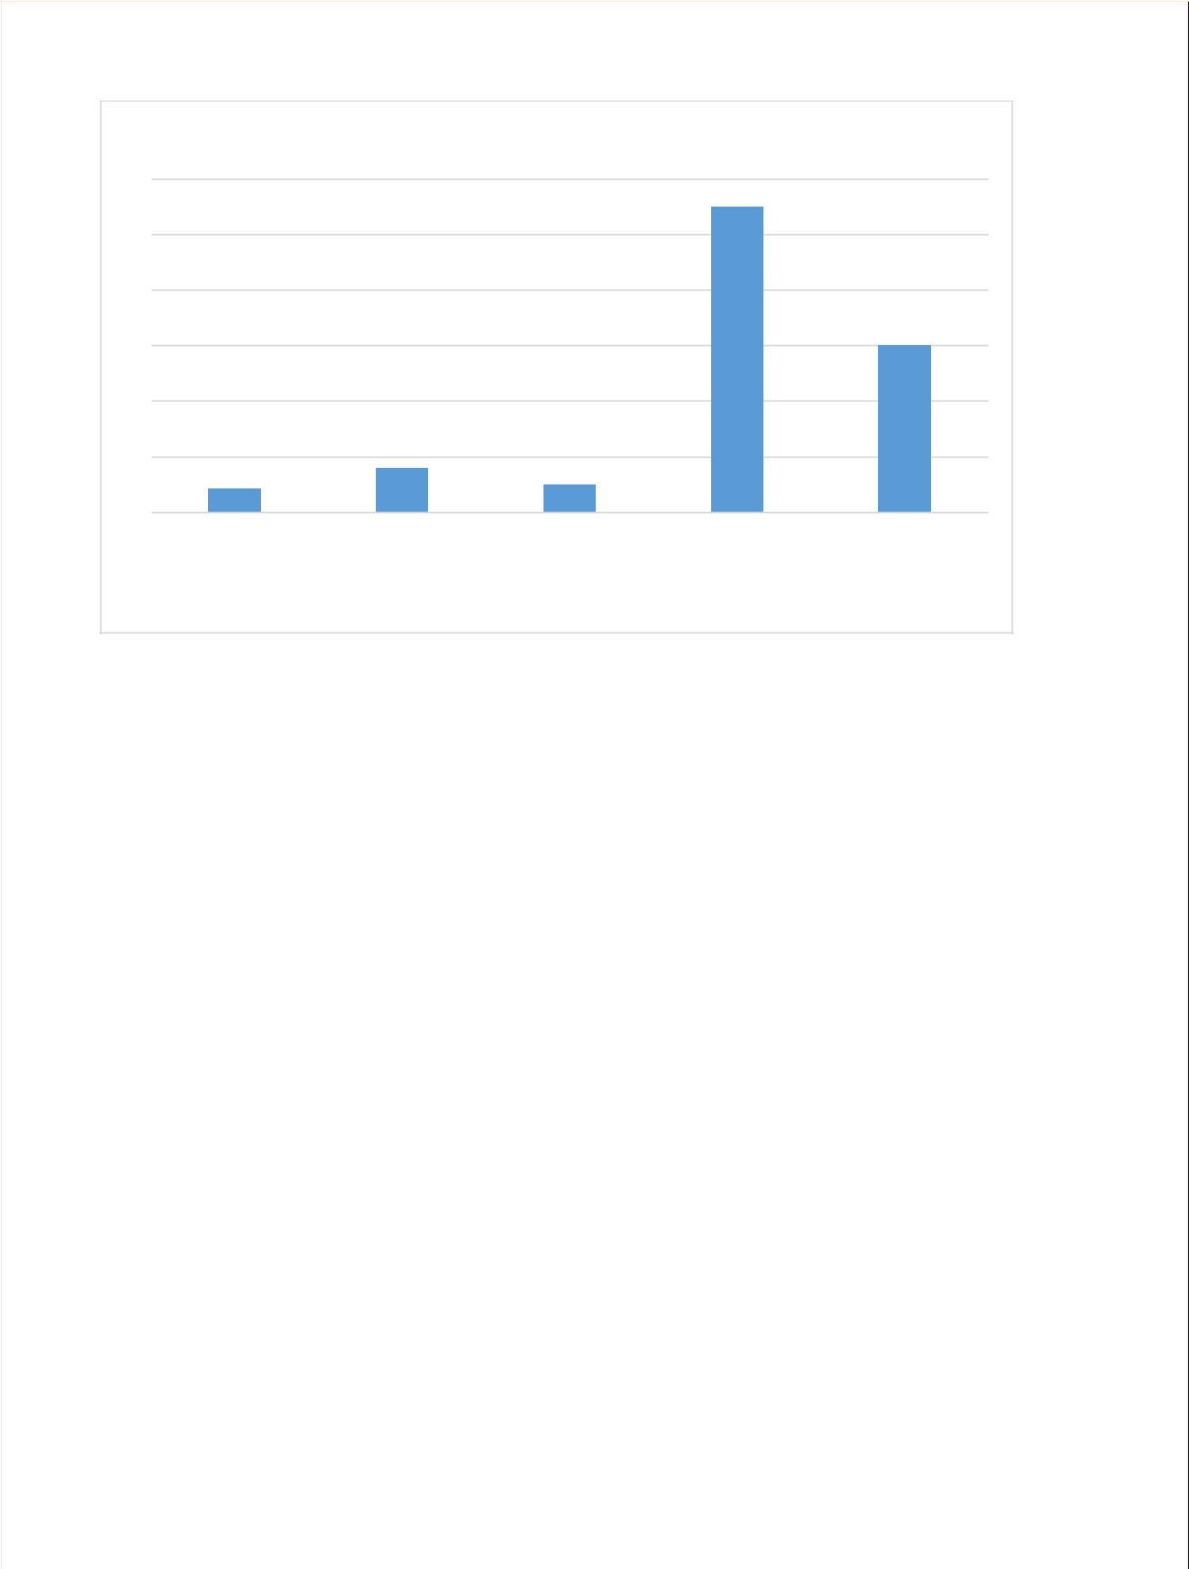
Products and Services

60

50

40

30

20

10

0

Buggy | Fine, But small |  | Fine | Great | Life Saving
 | problems
 |  |  | Products and Services

Are the products of Tesco able to fulfill the needs?

- Badly

- Fine

- Well

- Very Well

24 | P a g e

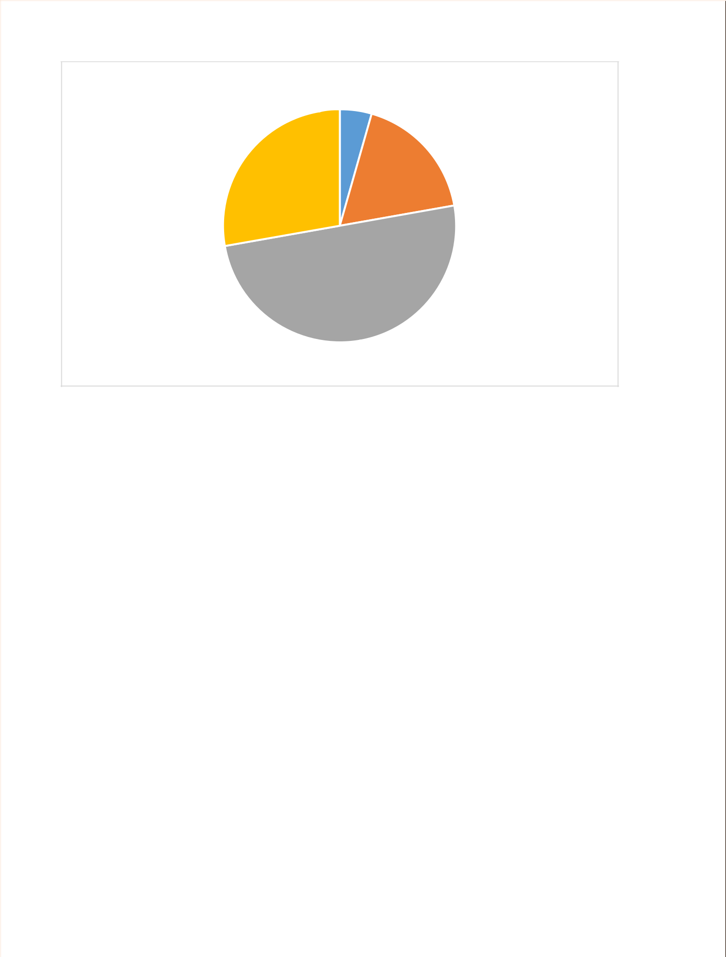
Fufllling the Need

Badly Fine Well

Very Well

How you would rate the value for money of the product of Tesco

a. Bad

b. Regular

c. Good
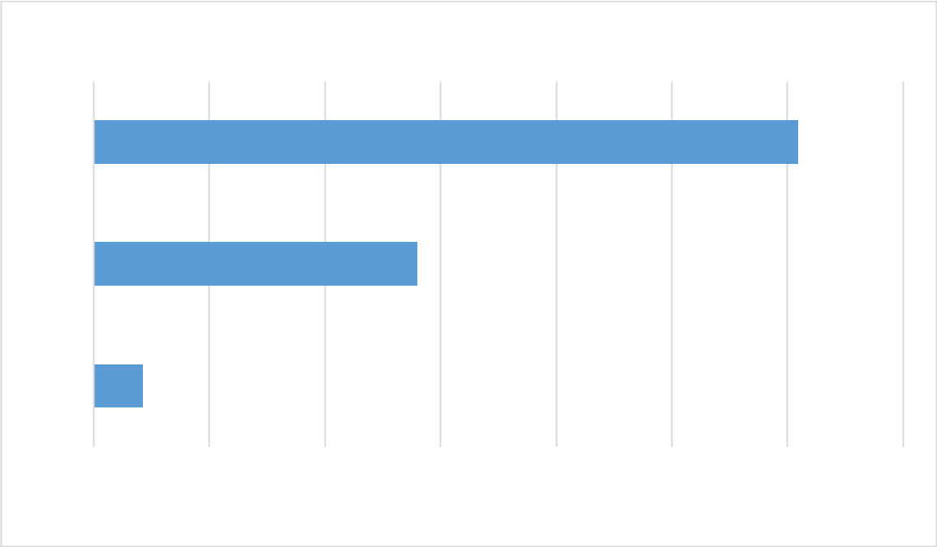

Value for Money

Good

Regular

Bad

0

10

20

30

40

50

60

70

Value for Money

25 | P a g e

How you feel while using website of Tesco?

- Very Difficult

- Difficult

- Regular

- Easy

- Very Easy
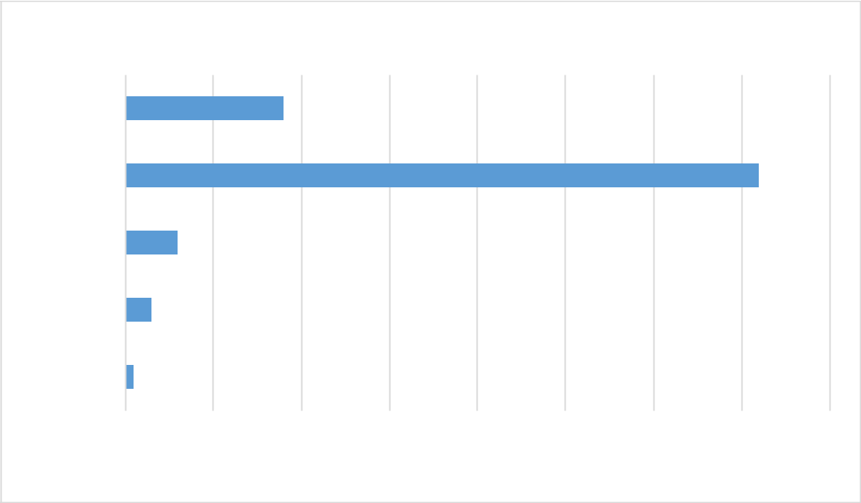

Ease of Using Website

Very Easy

Easy

Regular

Difficult

Very Difficult

0 10 20 30 40 50 60 70 80

Ease of Using Website

How you will rate quality of products of Tesco in comparison with competitors

- Better

- The Same

- Worse

26 | P a g e

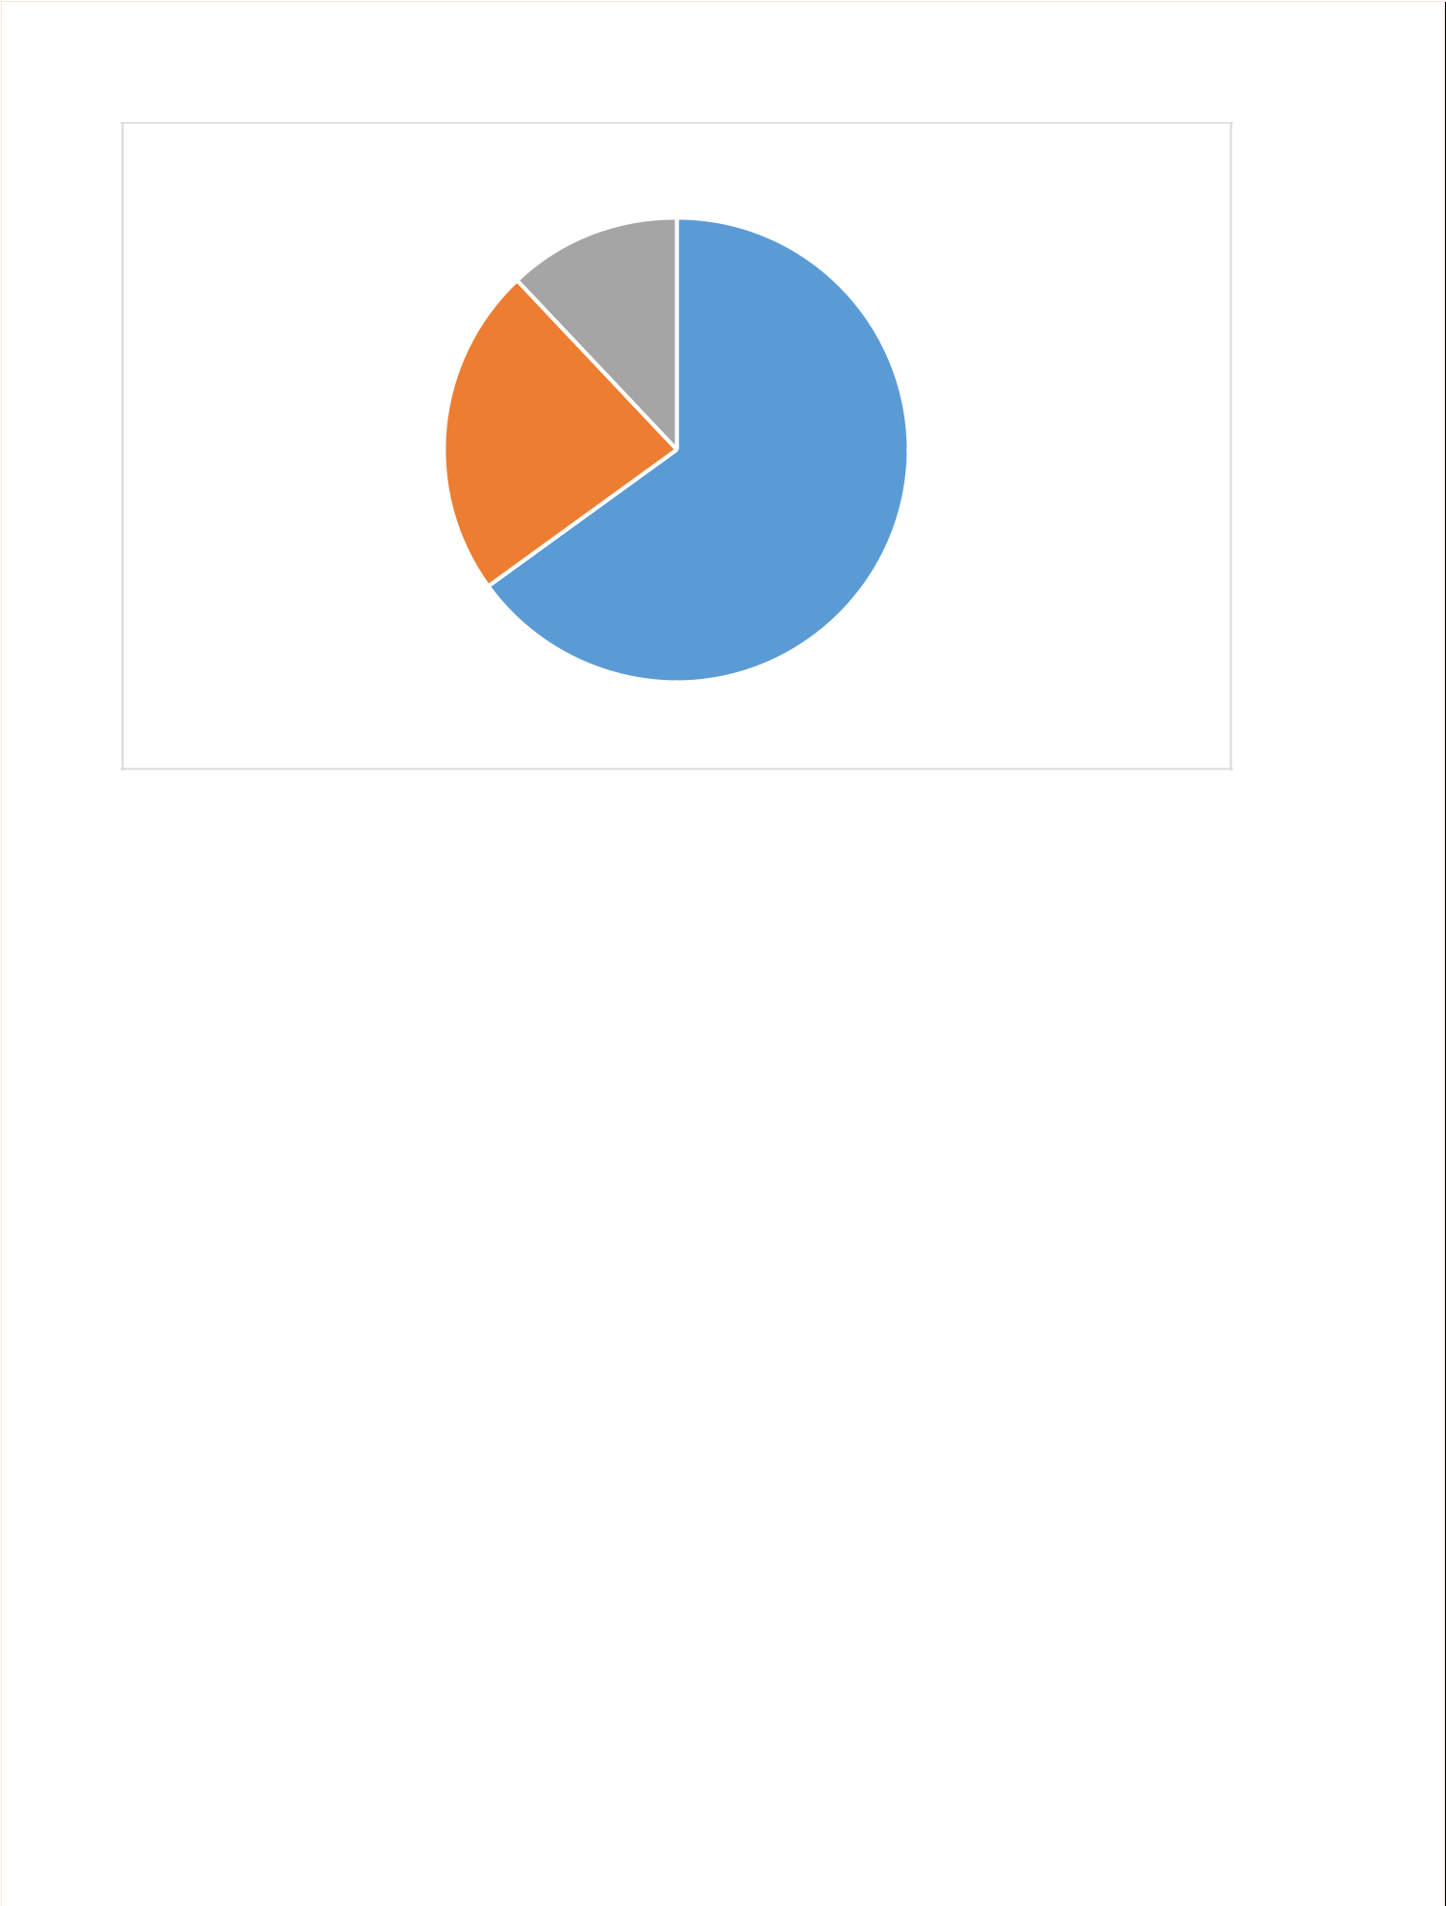
Competition with Others

Better Same Worse

27 | P a g e

4.3. Review the Success of a Completed Survey

The success of survey depends on various issues because various activities are related with completing the survey.

Preparation of Questions Based on Objectives: Firstly, Tesco had to prepare a questionnaire which will collect information about the satisfaction of customers. So, it has to ensure that the questions are set perfectly so that they can evaluate the answers to get idea that the customers are satisfied or not with the services of Tesco.

Sample Selection and Collection of Data: The selection of the respondents has played vital part to understand that the survey was successful or not. The researcher has selected 100 respondents who are the customers of different supermarket of UK. So, the survey has been successful in collecting information about the satisfaction of customers.

Achievement of Objectives: The success of the survey has also depended on the fact that whether the researcher has been able to achieve the objectives of the research (Wong, 2002). Here, the objective of the survey was to understand that whether the customers are satisfied with Tesco or not. And, the researcher has collected the information by conducting the survey.

Presenting the Findings of Survey: Most of the customers believe that the products and services of Tesco are able to fulfill the demands. At the same time, they have rated the products well. Customers of supermarket think that Tesco provide better quality products than its competitors. They found it easy to access the website of Tesco to purchase products and services from online. So, it can be said that the survey has been successful in all aspects.

28 | P a g e

Conclusion

Marketing intelligence include all the knowledge and strategies which needed by the organisation to capture the market and to operate business activities in the market. The report has helped to understand about the behaviour of the customers of Tesco and how the customers take decisions about purchasing any products and services. In addition, it has used some market research techniques for Tesco get some specific objectives. Through assessing the market size and future demand, the researcher has tried to get idea about the present condition of Tesco. Finally, it has measured that whether the customers are satisfied with the products and services of Tesco or not.

29 | P a g e

References

Arrow, K. and Hahn, F. (2007). General competitive analysis. Amsterdam: North-Holland.

Changing customer behaviour. (2007). [London]: BERR.

Doman, D., Dennison, D. and Doman, M. (2006). Market research made easy. North Vancouver, B.C.: International Self-Counsel Press.

Evans, M., Jamal, A. and Foxall, G. (2009). Consumer behaviour. Chichester, England: Wiley.

Facts, S. (2019). Topic: Supermarkets in the United Kingdom (UK). [online] www.statista.com. Available at: https://www.statista.com/topics/1983/supermarkets-in-the-united-kingdom-uk/ [Accessed 10 Feb. 2019].

Hair, J. (2014). Marketing Research. North Ryde: McGraw-Hill Education.

Kazanjian, K. (2013). Driving loyalty. New York: Crown Business.

Malhotra, N. (2017). Marketing Research. Pearson Education Limited.

Padua, D. (2014). Trust, social relations and engagement. [Place of publication not identified]:

Palgrave Macmillan.

Rossi, P., Wright, J. and Anderson, A. (2013). Handbook of Survey Research. Burlington: Elsevier Science.

Siji, S. (2015). Variance in Factors Influencing Buyer Behaviour Across Various Product Categories in FMCGs. Indian Journal of Marketing, 45(3), p.54.

Vaněk, M., Mikoláš, M. and Žváková, K. (2012). Evaluation Methods of Swot Analysis / Metody Vyhodnocení Swot Analýzy. GeoScience Engineering, 58(2), pp.23-31.

Widing, R. (2003). Customer behaviour. Melbourne: Thomson Learning.

Wong, T. (2002). Marketing research. [Singapore]: Marketing Institute of Singapore.

30 | P a g e

